Predicting Customer Reviews

Introduction
Customer reviews are a core part of feedback for any industry, stores and businesses will use them for information on what to improve on, and other customers will use them to determine if they want to give go with a certain company for their purchase. A good overall review rating can make or break some smaller stores and still have a large effect on even the biggest providers and their products. I wanted to see if we can predict customer reviews in the retail sector using some other common variables such as age, money spent, or time spent shopping as predictors. This data set is from Turkey, and while this prediction is on that population, its insights could be applied to customers around the world. A specific company that could benefit from this would be Amazon as they conduct business in Turkey and across the world.
Data Cleaning
For cleaning the data, I removed some of the columns that had identifier data (Order_ID, Customer_ID). I extracted the month from the date column and then turned that into 4 seasons in a season’s column, I then removed the date column. I checked the count of categories in the other categorical variables and found them to be acceptable. For numerical variables, I turned the discount amount into a Yes or No variables signaling if there was a discount or not. I removed Unit Price in favor of just keeping Total Amount. I had to log transform Total Amount as it was severely right skewed, this removed the skewness.
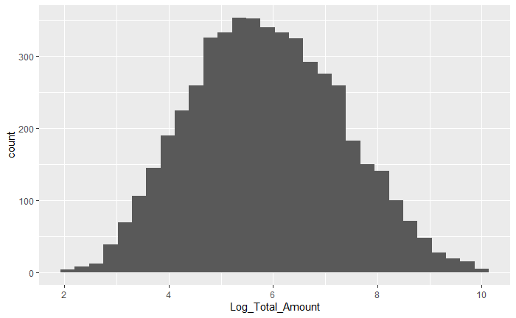

Model Selection and Performance
I chose to use linear regression and random forest to predict the customer review rating. For tuning parameters in random forest, I looked at tree splits for 2, 4 and 6 variables, as well as limiting the number of trees to 200 for better speed of running models. The results of the model were lackluster. I found that random forest performed slightly better, but the best model was still around a .879 MAE, which for a value between 1-5 is fairly large. The R Squared value was also very close to 0, showing that the model accounts for next to none of the variance in customer ratings. Finally, I found that the model had a negative percent variation explained value, which meant that a simple model like selecting just the mean values for customer ratings would provide a better prediction.
The two predictors that were most important to the model were the Log Total Amount and Session Duration Minutes. Again, since the model did not predict well, while these variables were the most important to the model they had a very small correlation with the response variable. Each was slightly positive in its correlation, with log total amount being at .003 and session duration minutes sitting at .026. 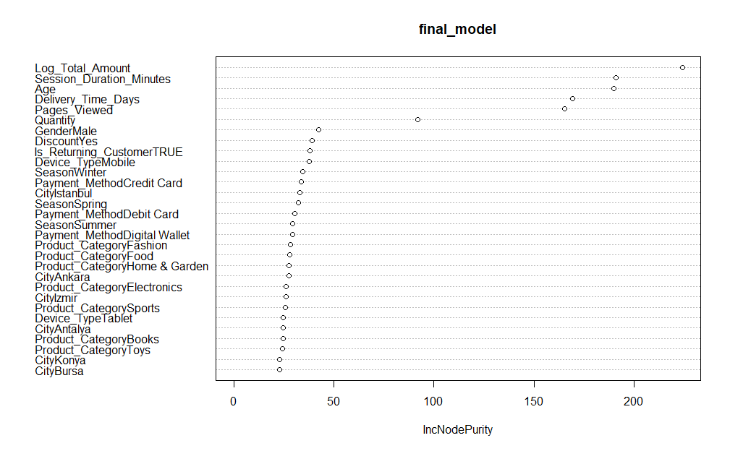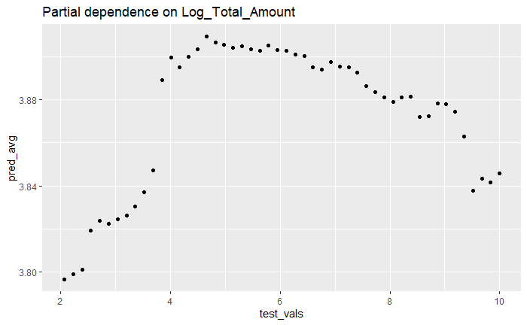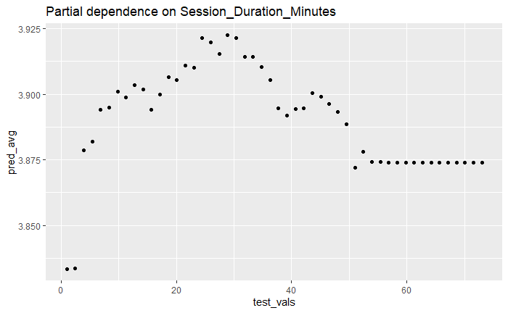
We can see the relationship a bit better here with the partial dependence plots. The trend for Log Total Amount is an increase to around the mid range of price, then a steady fall off for review rating as the prices got higher. The same goes for Session Duration Minutes, which may show that people are happy to do product research up to a certain point, and after about 30 minutes either they could get frustrated, or their expectations for the product may increase. We can see in this chart that there is little change for reviews overall based on price change.
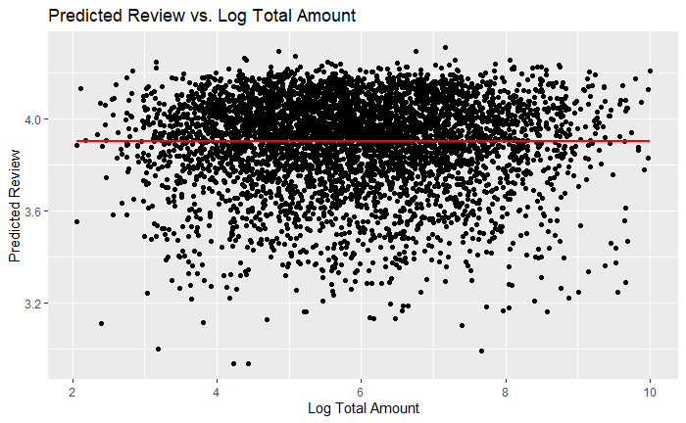
These two variables being the most important predictors does make sense as top values for many people are time and money. Money wise, if you spend more you likely expect more out of the product, this seems like the product does not keep up with expectations past a certain point, and then reviews see a negative effect on the higher end of spending. This makes sense as the products can only get so good, but companies do keep charging more and more, sometimes for the same product. Session duration minutes also makes sense, in that people will think that the time they spend researching a product is worthwhile only up to a certain point, about 30 minutes, and after that they may start to expect more out of what they buy, or get frustrated at the amount of time they had to spend to find the item they were looking for.
Since the performance of the model was so poor, I would say the model is not sufficiently accurate to be used for new predictions of customer review ratings. In the future I would recommend that we need more and different predictors that relate better to what makes a customer leave a review. I believe variables such as average previous reviews, condition of product received are important as some people love to leave either good or bad reviews consistently, as well as typically people are more inspired to leave a review when they receive something in non-optimal condition. Other demographic variables such as household income could be important as well to see if this was a big purchase and it came in subpar condition we could likely better predict that to be a worse review.

Conclusion
This model was not effective in better predicting customer review scores than a simple model. Customer review scores are difficult to predict since people will leave good or bad reviews for many different reasons, and it is difficult to get the proper predictor variables needed to understand these reasons as they can change from person to person. This makes it very difficult for future predictions.

